**WD Assignment**



Submitted By:

-----------------------------

**Nitish Raj**

**11720068**

**IT 3**

Submitted To:

----------------------------

**Meenakshi Sharma Ma’am**

1. **Working with text**

<html>

<head>

<title>Working With Text</title>

</head>

<body>

This is normal text<br>

<b>This is bold text<br></b>

<i>This is italic text<br></i>

<u>This is underlined text<br></u>

<h1>Text in heading 1</h1>

<h2>Text in heading 2</h2>

<h3>Text in heading 3</h3>

<h4>Text in heading 3</h4>

<h5>Text in heading 3</h5>

<h6>Text in heading 3</h6>

</body>

</html>

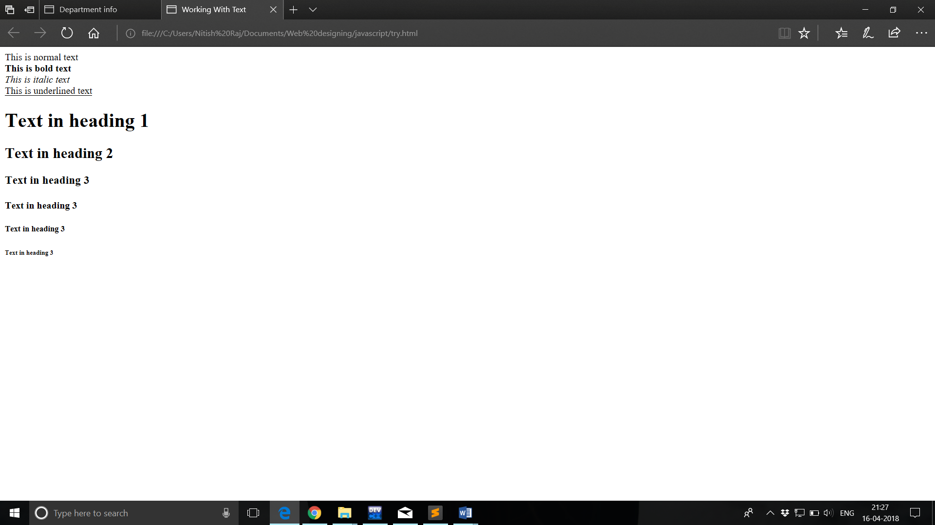

1. **Working with list.**

<html>

<body>

<p><u><b>Examples of Ordered List</b></u></p>

<ol>

<li>MI</li>

<li>Samsung</li>

<li>Apple</li>

<li>Moto</li>

</ol>

<p><u><b>Examples of Unordered List</b></u></p>

<ul>

<li>Photoshop</li>

<li>Autocad</li>

<li>VLC media player</li>

<li>McAfee</li>

</ul>

<p><u><b>Examples of Detailed List</b></u></p>

<dl>

<dt>Facebook</dt>

<dd>- Instagram</dd>

<dt>Google</dt>

<dd>- Gmail</dd>

</dl>

</body>

</html>

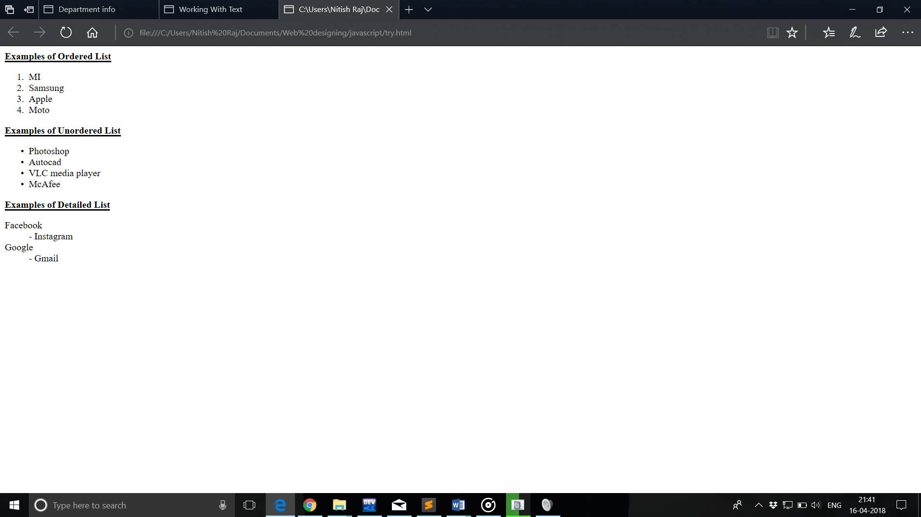

1. **Resume**

<html>

<head>

<title>My Resume</title>

<meta name="author" content="Nitish Raj">

<meta name="viewport" content="width=device-width, initial-scale=1">

<style>

#body{

font-size: 120%;

margin-left: 200px;

margin-right: 200px;

width: 1000px;

border: 3px solid black;

padding: 5px;

}

#heading{

background: #fff;

font-size: 20px;

font-weight: 700px;

text-align: center;

padding: 2px;

margin: 5px;

margin-bottom: 10px;

color: white;

border-radius: 10px;

border: 1px solid darkgreen;

box-shadow: inset 3px 3px 200px 10px lightgreen, inset -3px -3px 15px 2px black;

text-shadow: 4px 2px black;

}

#name{

border: 2px solid black;

padding: 4px;

margin: 5px 0px 7px 10px;

padding-left: 20px;

width: 340px;

height: auto;

}

table{

text-align: center;

border: 2px solid black;

padding: 10px;

margin: 5px 3px 3px 5px;

}

ul{

list-style-type: square;

}

h5{

font-size: 17px;

background-color: lightgray;

margin: 0px 0px 0px 0px;

}

#sign{

float: right;

margin-right: 50px;

}

</style>

</head>

<body>

<div id="body">

<div id="heading">

<h1>My Resume </h1>

</div>

<hr size="1px" color="black"/>

<hr size="1px" color="black"/>

<div>

<img src="C:\Users\Nitish Raj\Downloads/profile.jpg" width="200" height="200px" alt="me" style="float: right; margin: 15px 180px 0px 0px; border: 5px solid rgba(30, 30, 30, 0.4); outline: 1px solid green; outline-offset: 10px; border-radius: 100px">

</div>

<div id="name">

<h2>Nitish Raj</h2>

<h3>B.Tech, Information Techonology

<BR/>NIT KURUKSHETRA</h3>

<h4>Contact No. 8295232047<br>E-mail: nitishraj.swordmaster@gmail.com</h4>

</div>

<hr size="2px" color="black" width="1000px" align="center">

<u><b>Present Address: </b></u>&nbsp;Krishna Nagar, kankhal, Haridwar 249407

<hr size="2px" color="black" width="1000px" align="center">

<div>

<H5>CAREER OBJECTIVE</H5>

To work in a firm with a professional work driven envionment where I can utilize and apply my knowledge, skills which would enable me as a fresh graduate to grow while fulfilling organizational goals.

</div>

<br>

<div><h5>BASIC ACADEMIC CREDENTALS</h5>

<table border="2px" cellpadding="10px" cellspacing="3px" width="98%">

<th>

Qualification

</th>

<th>

Board/University

</th>

<th>

Year

</th>

<th>

Percentage

</th>

<tr>

<td>B.Tech(Information Technology)</td>

<td>NIT Kurukshetra</td>

<td>2017-2021</td>

<td>9.03/10</td>

</tr>

<tr>

<td>Intermediate</td>

<td>CBSE</td>

<td>2016</td>

<td>90%</td>

</tr>

<tr>

<td>High School</td>

<td>CBSE</td>

<td>2014</td>

<td>95%</td>

</tr>

</table>

</div>

<div>

<H5>IT PROFICIENCY</H5>

<ul>

<li>Microssoft Office Word, Microsoft Office Excel, Microsoft Office Power Point</li>

<li>Language C, C++, JAVA, PHP</li>

<li>General and graphic application: HTML, JavaScript</li>

</ul>

</div>

<div><h5>CO-/EXTRA-CURRICULAM ACTIVITIES</h5>

<ul>

<li>Member of Technical Community in NIT Kurukshetra</li>

</ul>

</div>

<div>

<h5>

ACHIEVEMENTS

</h5>

<ul>

<li>Actively participated in various sport activities for inter school.</li>

<li>Won a bronze medal in football in 2015.</li>

</ul>

</div>

<div>

<h5>

INTERPERSONAL SKILLS

</h5>

<ul>

<LI>Ability to rapidly build relationship and set up trust.</LI>

<li>Confident and Determined.</li>

<li>Ability to cope up with different situations.</li>

</ul>

</div>

<div>

<h5>

REFERENCES

</h5><br>

<B>P. Selvam,</B> Principal Of JNV Khairabad <br>

<b>M. Kalyani,</b> Principal Of JNV Gadag <br>

<b>Kanupriya Kashyap,</b> Faculty, NIT Kurukshetra <br><br>

</div>

<div>

<h5>PERSONAL DETAILS</h5>

<ul>

<li>Fathers's Name: Mr. Singh Raj</li>

<li>Permanent Address: Krishna Nagar, kankhal, Haridwar 249407</li>

<li>Date of Birth: 27-June-1998</li>

<li>Language Known: Hindi & English</li><li>Marital Status: Single</li>

<li>Nationality/Religion: Indian/Hindu</li><li>Interest & Hobbies: Internet Browsing, reading novel

</li>

</ul>

</div>

<div>

<h5>DECLARATION</h5>

<br>

I do hereby declare that the above information is true to the best of my knowledge.

<br><br><br><br>

<div id="sign"><b>Nitish Raj<br></b>&nbsp;&nbsp;(Signature)</div>

Place: ..................

<br>

Date:

</div>

</div>

</body>

</html>

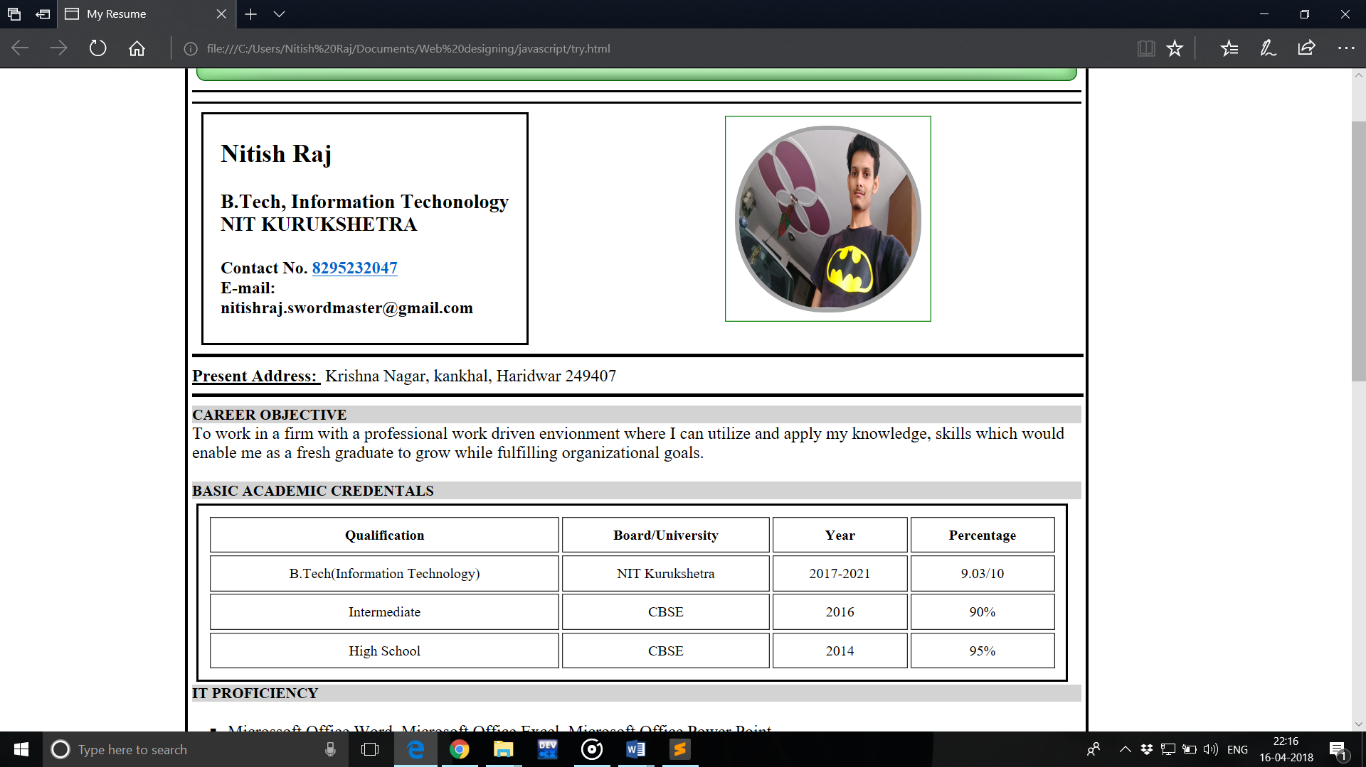

1. **Time Table**

<html>

<table border=5 bgcolor="white" bordercolor="black" cellpadding=10 cellspacing=0 width=100%>

<th colspan="10"><h3>Time Table</h3></th>

<tr>

<td>1</td><td>2</td><td>3</td><td>4</td><td>5</td><td>6</td><td>7</td><td>8</td><td>9</td><td>10</td>

</tr>

<tr>

<td>MA-L</td><td>1DC-L</td><td>2DC-L</td><td> </td><td> </td><td> </td><td> </td><td>EE-L</td><td> </td><td> </td>

</tr>

<tr>

<td colspan="3">WD</td><td> </td>

<td>3DC-L</td><td>2DC-L</td><td>PH-L</td><td colspan="2">2DC-P</td><td> </td>

<tr>

<td>EE-L</td><td>3DC-L</td><td>1DC-L</td>

<td> </td><td colspan="2">CH-P</td><td>MA-L</td><td> </td><td COLSPAN="2">PH-P</td>

</tr>

<tr>

<td>PH-L</td><td>3DC-L</td><td>EE-T</td><td> </td><td> </td>

<td>MA-T</td><td> </td><td>3DC-P</td><td> </td><td> </td>

</tr>

<tr>

<td>1DC-L</td><td>2DC-L</td><td>MA-L</td><td> </td><td>CH-T</td><td>PH-T</td><td>CH-L</td><td>WD-L</td><td> </td><td> </td>

</tr>

</table>

</body>

</html>

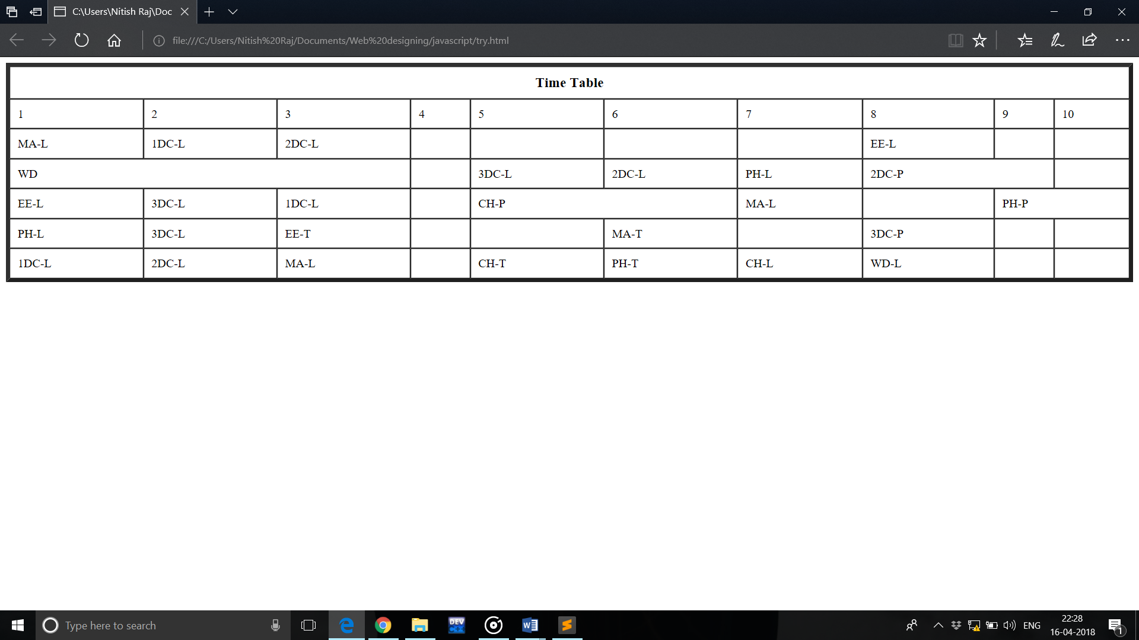

1. **Frameset**

<html>

<frameset cols="50%,50%">

<frame src="E:\NR\HTML\EXP1/NRQ1a.html">

<frame src="E:\NR\HTML\EXP1/form.html">

</frameset>

</html>

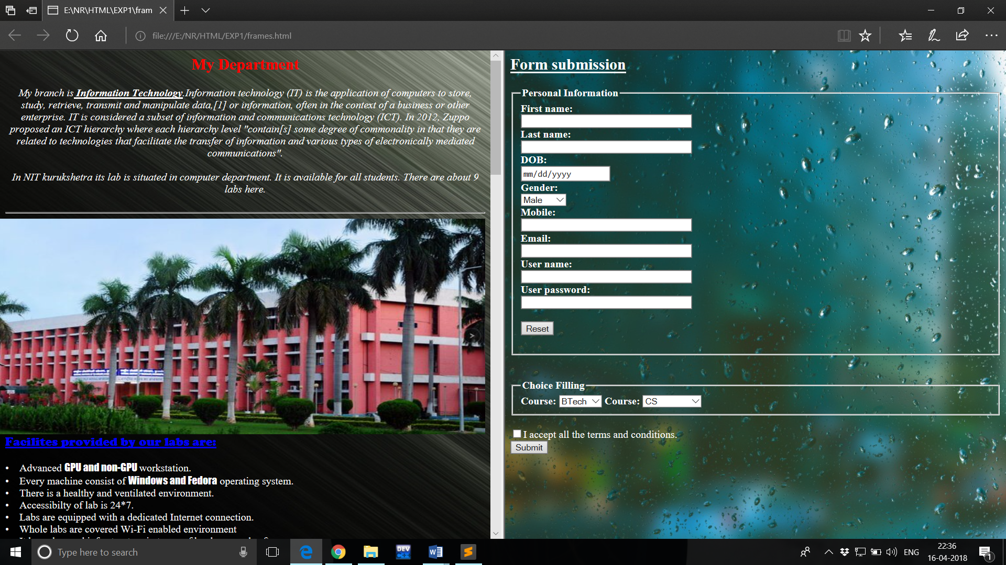

1. **Forms**

<html>

<body background="E:\NR\HTML\EXP1/back1.jpeg">

<font color="white">

<h2><u>Form submission</u></h2>

<form>

<fieldset>

<legend><b>Personal Information</b></legend>

<b>First name:</b><br>

<input type="text" name="firstname" size="40" required>

<br>

<b>Last name:</b><br>

<input type="text" name="lastname" size="40" required><br>

<b>DOB:</b><br>

<input type="date"><br>

<b>Gender:</b><br>

<select>

<option value="Male">Male</option>

<option value="Female">Female</option>

<option value="Other">Other</option>

</select><br>

<b>Mobile:</b><br>

<input type="text" name="Mobile" size="40" required><br>

<b>Email:</b><br>

<input type="email" name="Email" size="40" required><br>

<input type="submit">

</fieldset>

<br><br>

</form>

</font>

</body>

</html>

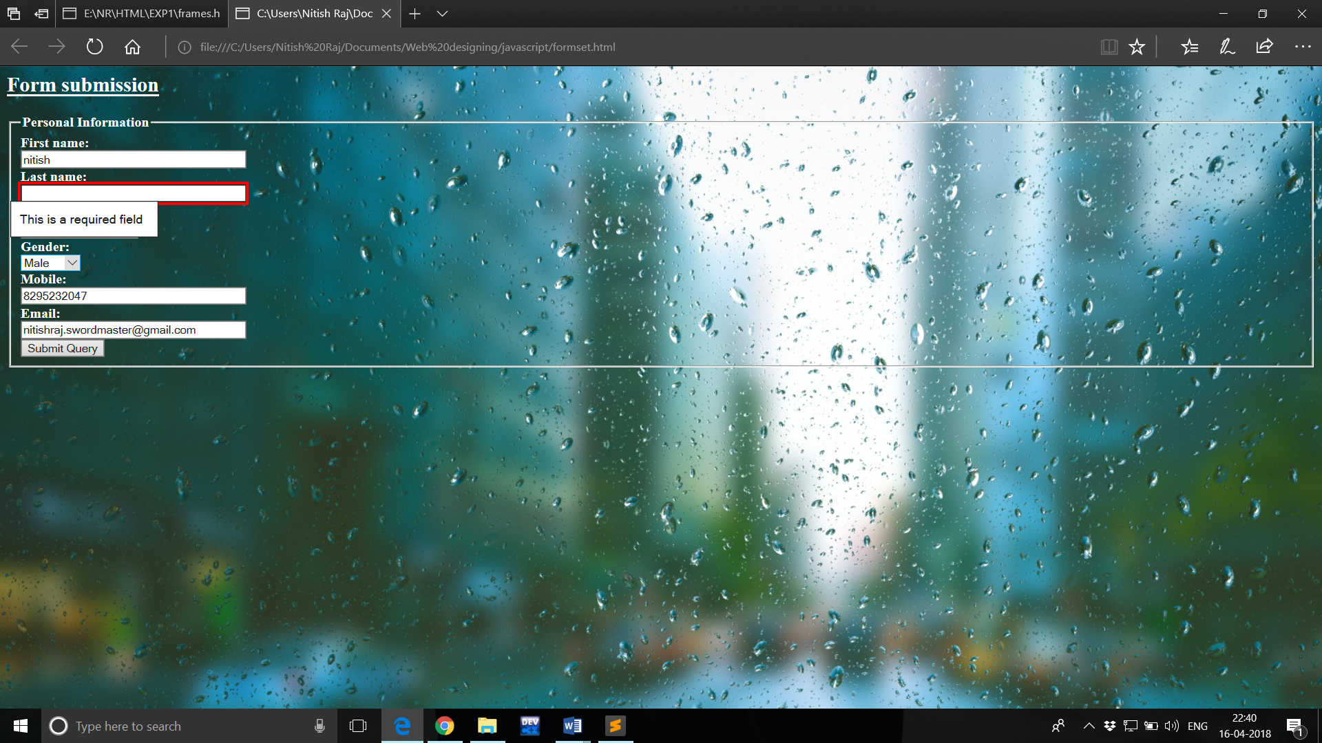

1. **Image Map Tag**

<html>

<body>

<h2>Image Maps</h2>

<p>Click on the Haryana,to go to a new page and see the map of haryana:</p>

<img src="india-map.jpg" usemap="#map" width="800" height="679">

<map name="map">

<area shape="circle" coords="240,200,40,40" alt="haryana" href="haryana.jpg">

</map>

</body>

</html>

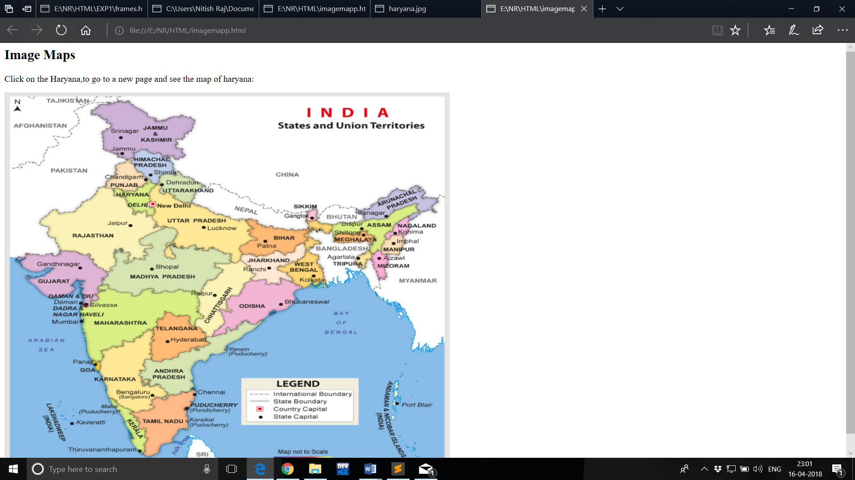

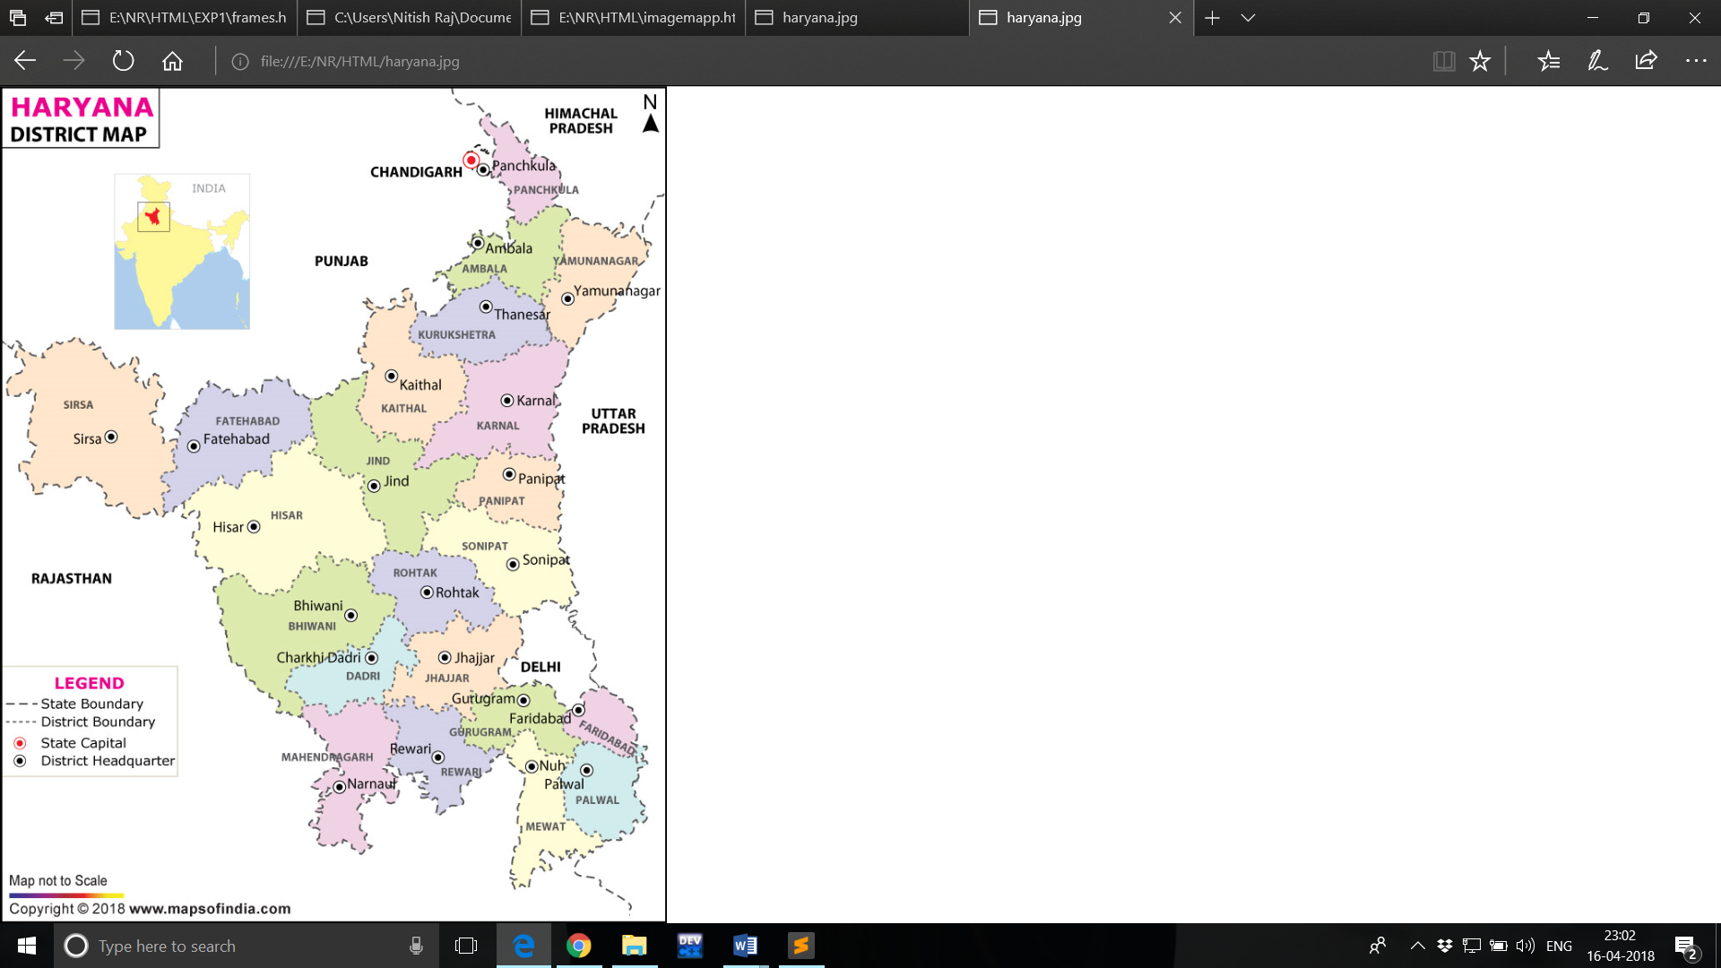

1. **CSS**

<html>

<head>

<style>

p{

background-color: green;

}

</style>

<link rel="stylesheet" type="text/css" href="external.css">

</head>

<body>

<p style="background-color: red";>This is an example of css inline linking

</p>

<p>

This is an example of css internal linking

</p>

<h3>

This is an example of external linking

</h3>

</body>

</html>

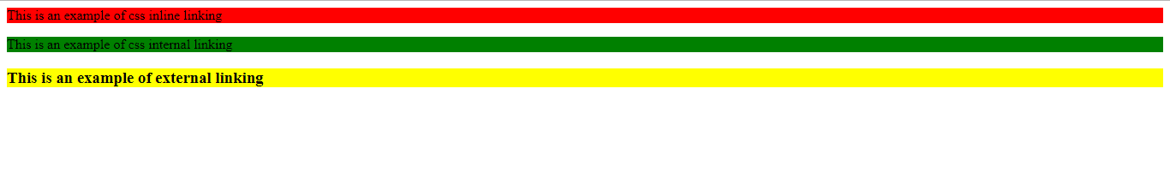

1. **Audio and Video**

<!DOCTYPE html>

<html>

<head>

<title>audio</title>

</head>

<body background="E:\NR\HTML\EXP1/back2.jpg">

<h2 style="text-align:center;"><u>Activities</u></h2>

&emsp;&emsp;&emsp;<video src="E:\NR\HTML\EXP1/activity.mp4" height="400" width="400" controls></video>&emsp;&emsp;

<video src="E:\NR\HTML\EXP1/activity2.mp4" height="400" width="400" controls></video>&emsp;&emsp;

<video src="E:\NR\HTML\EXP1/activity3.mp4" height="325" width="400" controls></video>

<audio controls>

<source src="C:\Users\Nitish Raj\Videos/Hothon Se Chhu Lo Tum (The Unwind Mix) by Mohammed Irfan.mp3" type="audio/mp3"></audio>

</body>

</html>

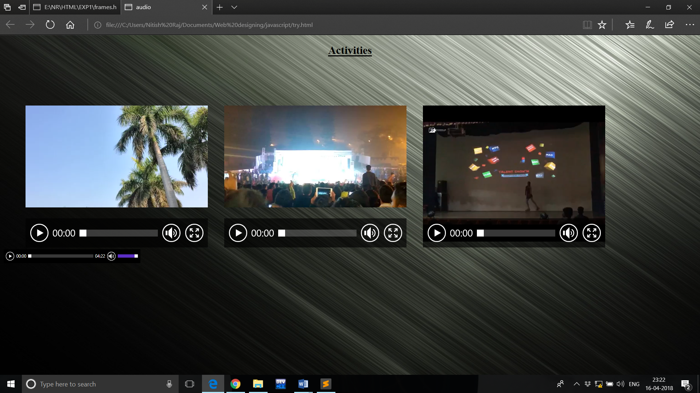

**Javascripts**

1. **Prime Numbers**

<!DOCTYPE html>

<html>

<head>

<title>To check for a prime number</title>

<script type="text/javascript">

function prime()

{

var n,i,flag=0;

n=document.f.n.value;

for(i=2;i<n;i++)

{

if(n%i==0)

{

flag++;

break;

}

}

if(flag==0)

document.getElementById("1").innerHTML=" Prime number";

else

document.getElementById("1").innerHTML="Not Prime number";

}

</script>

</head>

<body>

<center>

<h1>To check whether a given number is prime or not</h1>

<hr color="red">

<form name="f">

Enter the number:<input type="text" name="n" value=""><br><br>

<input type="button" value="Check" onclick="prime()"><br>

<p id="1">

</center>

</form>

</body>

</html>

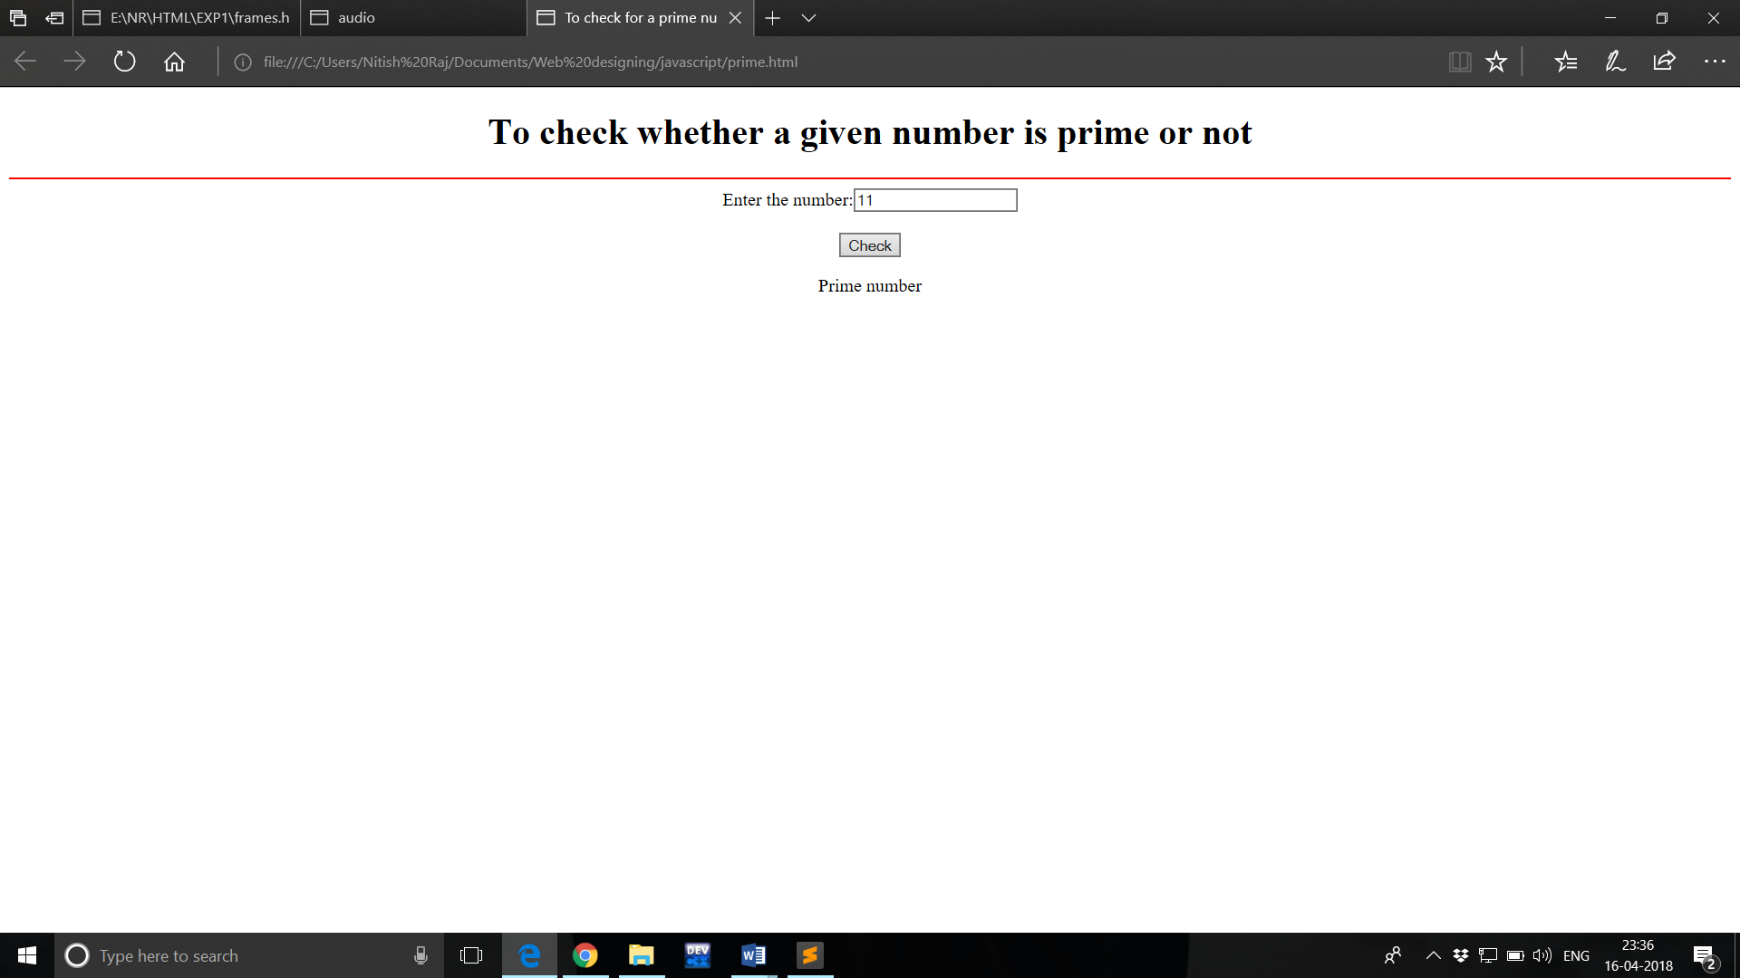

1. **Search an Element in an array**

<!DOCTYPE html>

<html>

<head>

<title>Searching in Array</title>

<script type="text/javascript">

function searching()

{

var n,i;

n=parseInt(document.f.n.value);

if(n=="")

alert("Please enter the size");

else

{

var a=new Array(n);

for(i=0;i<n;i++)

{

var num=prompt("Enter the number","");

a[i]=parseInt(num);

}

var search=parseInt(prompt("Enter the number you want to search",""));

var p=1;

var x="";

for(i=0;i<n;i++)

{

x=x+a[i]+" ";

if(a[i]==search)

{

p=p+i;

}

}

document.getElementById("1").innerHTML="Array : "+x;

if(p>1)

document.getElementById("ans").innerHTML=search+" is present at position "+p;

else

document.getElementById("ans").innerHTML=search+" is not present in the array";

}

}

</script>

</head>

<body>

<center>

<h1>To find any number present in the array.</h1>

<hr color="red">

<form name="f">

Enter the array size:<input type="text" name="n" value=""><br><br>

<input type="button" value="Submit" onclick="searching()"><br><br>

<p id="1">

<p id="ans">

</form>

</center>

</body>

</html>

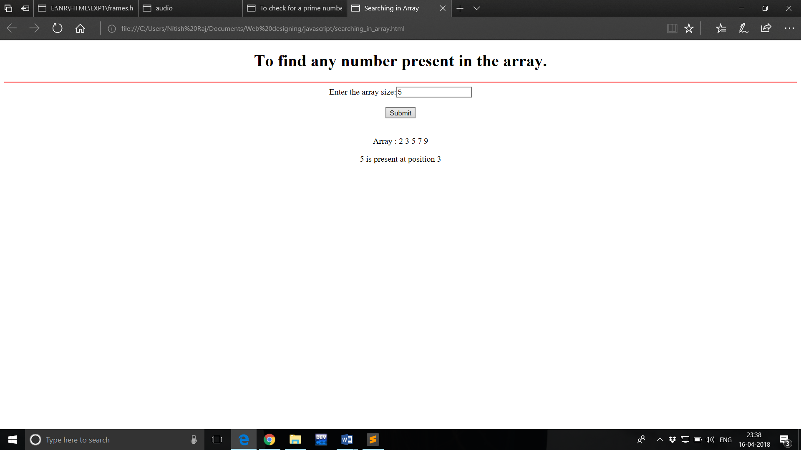

1. **G.C.D of two numbers**

<!DOCTYPE html>

<html>

<head>

<title>Greatest common factor</title>

<script type="text/javascript">

function gcd()

{

var x=parseInt(document.f.x.value);

var y=parseInt(document.f.y.value);

while(x!=y)

{

if(x>y)

x=x-y;

else

y=y-x;

}

document.getElementById("1").innerHTML="The greatest common factor is "+x;

}

</script>

</head>

<body>

<center>

<h1>Greatest common factor</h1>

<hr color="red">

Enter two Numbers:<br><br>

<form name="f">

First no.<br><input type="text" name="x" value=""><br>

Second no.<br><input type="text" name="y" value=""><br><br>

<input type="button" value="Check" onclick="gcd()"><br><br>

<p id="1">

</center>

</form>

</body>

</html>

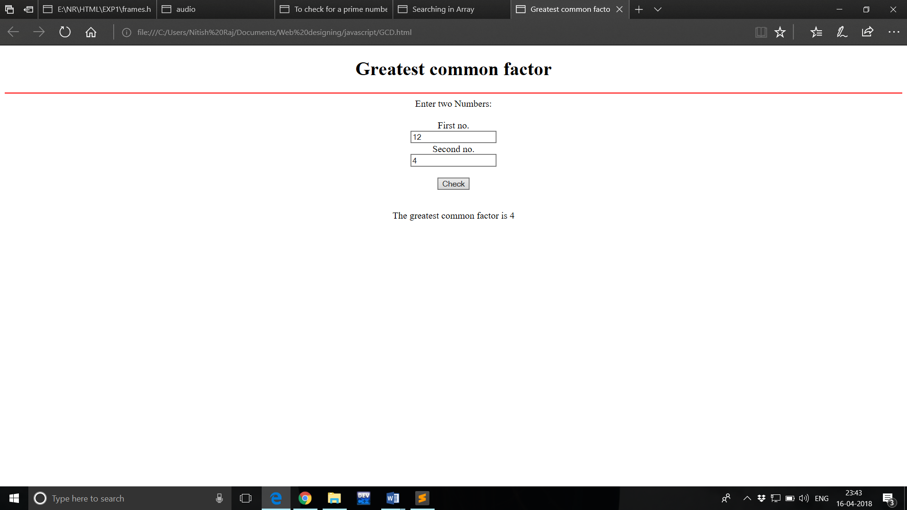

1. **Calculator**

<html>

<head>

<center><body>

<form name="calculator">

<table border='6'>

<th colspan="4">Calculator</th>

<tr>

<td colspan="4">

<input type="text" name="display" id="display" disabled>

</td>

</tr>

<tr>

<td><input type="button" style="width:100%" name="one" value="1" onclick="calculator.display.value += '1'"></td>

<td><input type="button" style="width:100%" name="two" value="2" onclick="calculator.display.value += '2'"></td>

<td><input type="button" style="width:100%" name="three" value="3" onclick="calculator.display.value += '3'"></td>

<td><input type="button" style="width:100%" class="operator" name="plus" value="+" onclick="calculator.display.value += '+'"></td>

</tr>

<tr>

<td><input type="button" style="width:100%" name="four" value="4" onclick="calculator.display.value += '4'"></td>

<td><input type="button" style="width:100%" name="five" value="5" onclick="calculator.display.value += '5'"></td>

<td><input type="button" style="width:100%" name="six" value="6" onclick="calculator.display.value += '6'"></td>

<td><input type="button" style="width:100%" class="operator" name="minus" value="-" onclick="calculator.display.value += '-'"></td>

</tr>

<tr>

<td><input type="button" style="width:100%" name="seven" value="7" onclick="calculator.display.value += '7'"></td>

<td><input type="button" style="width:100%" name="eight" value="8" onclick="calculator.display.value += '8'"></td>

<td><input type="button" style="width:100%" name="nine" value="9" onclick="calculator.display.value += '9'"></td>

<td><input type="button" style="width:100%" class="operator" name="times" value="x" onclick="calculator.display.value += '*'"></td>

</tr>

<tr>

<td><input type="button" style="width:100%" id="clear" name="clear" value="c" onclick="calculator.display.value = ''"></td>

<td><input type="button" style="width:100%" name="zero" value="0" onclick="calculator.display.value += '0'"></td>

<td><input type="button" style="width:100%" name="doit" value="=" onclick="calculator.display.value = eval(calculator.display.value)"></td>

<td><input type="button" style="width:100%" class="operator" name="div" value="/" onclick="calculator.display.value += '/'"></td>

</tr>

</table>

</form>

</body>

</center>

</head>

</html>

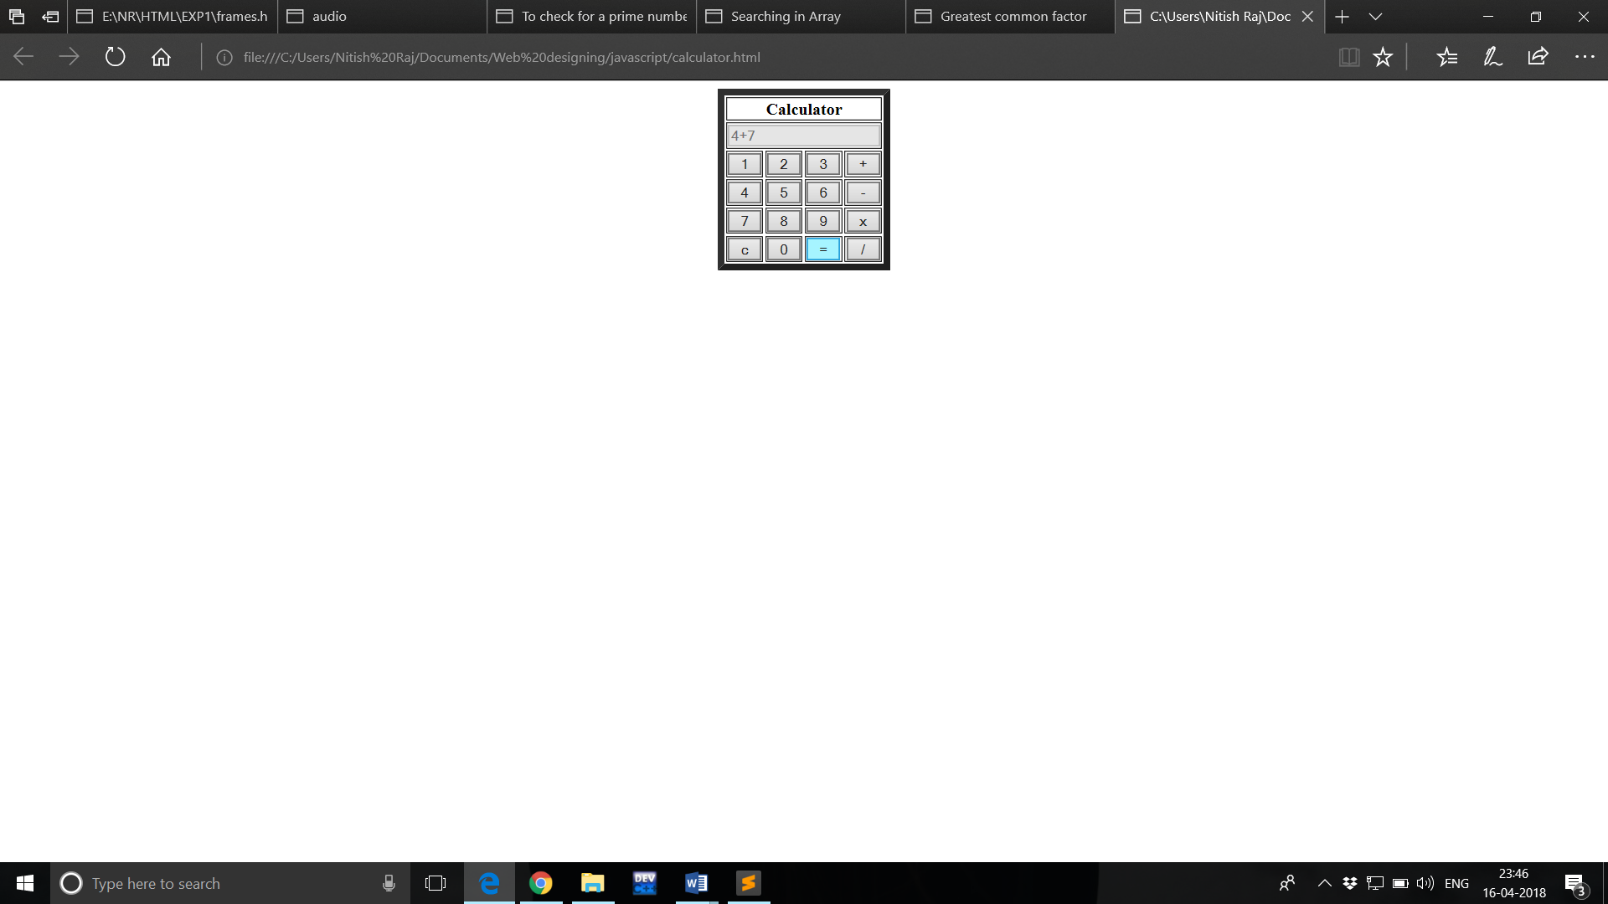

1. **Built-in Functions**

<html>

<body>

<script type="text/javascript">

var s="Welcome Home";

document.write("<center>");

document.write("<h1>Example for String Functions</h1>");

document.write("<hr color=red>");

document.write(s.big()+"<br>");

document.write(s.small()+"<br>");

document.write(s.bold()+"<br>");

document.write(s.italics()+"<br>");

document.write(s.fixed()+"<br>");

document.write(s.strike()+"<br>");

document.write(s.sup()+"<br>");

document.write(s.sub()+"<br>");

document.write(s.blink()+"<br>");

document.write(s.fontcolor("green")+"<br>");

document.write(s.fontsize(6)+"<br>");

document.write("</center>");

</script>

</body>

</html>

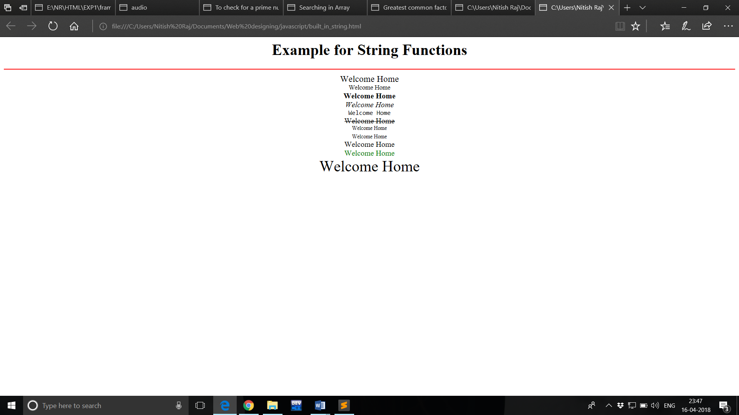

Math Function

<!DOCTYPE html>

<html>

<head>

<title>Math Functions</title>

</head>

<body>

<center><h1>Math functions</h1></center>

<hr size="2" color="red">

<ul>

<li><p>Math.round(x) returns the value of x rounded to its nearest integer:</p>

<p id="1"></li>

<li><p>Math.pow(x,y) returns the value of x to the power of y:</p>

<p id="2"></li>

<li><p>Math.sqrt(x) returns the square root of x:</p>

<p id="3"></li>

<li><p>Math.abs(x) returns the absolute (positive) value of x:</p>

<p id="4"></li>

<li><p>Math.ceil() rounds a number upto to its nearest integer:</p>

<p id="5"></li>

<li><p>Math.floor() rounds a number upto to its nearest integer:</p>

<p id="6"></li>

<li><p>Math.min() returns the lowest value in a list of arguments:</p>

<p id="7"></li>

<li><p>Math.max() returns the highest value in a list of arguments.</p>

<p id="8"></li>

<li><p>Math.random() returns a random number between 0 and 1:</p>

<p id="9"></li>

<script type="text/javascript">

document.getElementById("1").innerHTML = Math.round(4.6);

document.getElementById("2").innerHTML = Math.pow(4,3);

document.getElementById("3").innerHTML = Math.sqrt(64);

document.getElementById("4").innerHTML = Math.abs(-4.4);

document.getElementById("5").innerHTML = Math.ceil(5.2);

document.getElementById("6").innerHTML = Math.floor(5.2);

document.getElementById("7").innerHTML = Math.min(0, 150, 30, 20, -8, -200);

document.getElementById("8").innerHTML = Math.max(0, 150, 30, 20, -8, -200);

document.getElementById("9").innerHTML = Math.random();

</script>

</body>

</html>

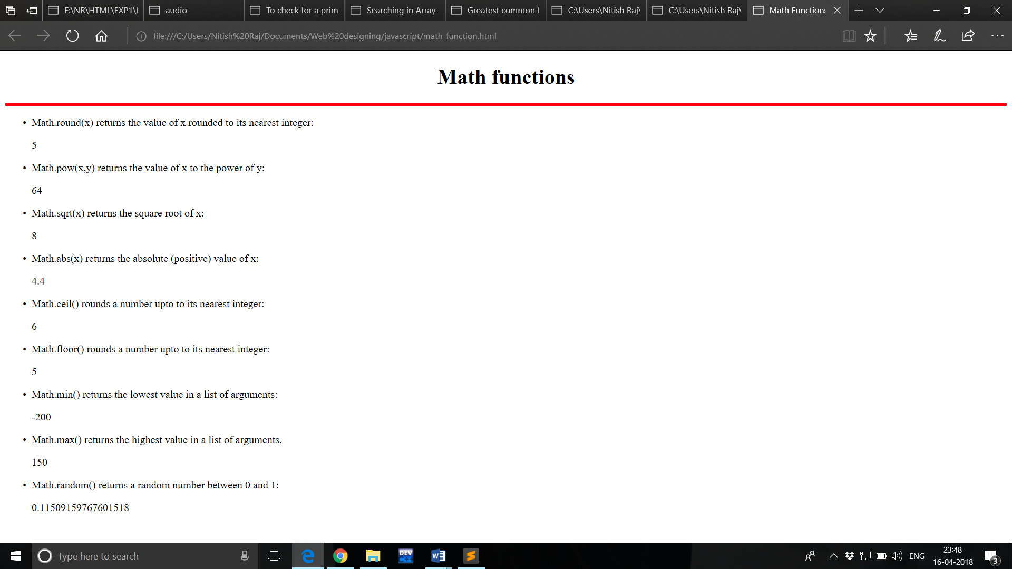

1. **Digital Clock**

<html>

<head>

<title>Digital Clock</title>

<style>

#clock{

color:#F01;

}

</style>

</head>

<body>

<script>

function digclock()

{

var d = new Date()

var t = d.toLocaleTimeString()

document.getElementById("clock").innerHTML = t;

}

setInterval(function(){digclock()},500)

</script>

<h1 style="text-align:center;">---DIGITAL CLOCK---<h1>

<div style="font-size:150px; text-align:center;" id="clock">

</div>

</body>

</html>

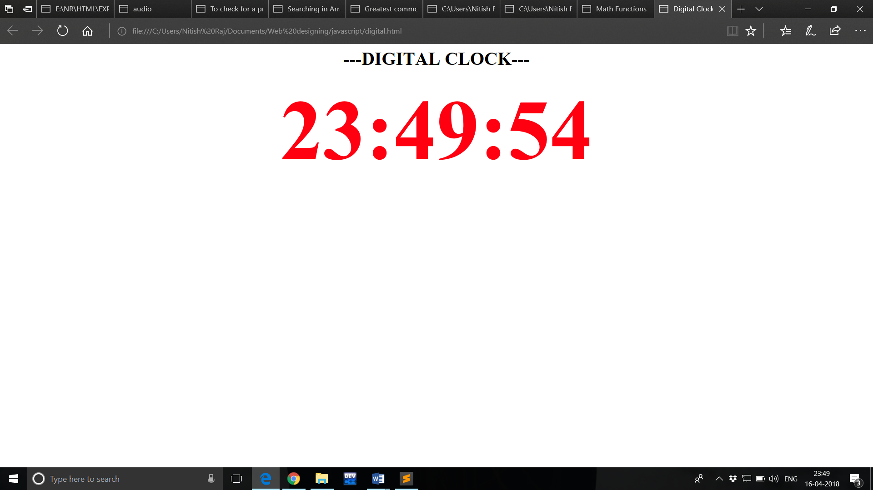

1. **Form Validation**

<!DOCTYPE html>

<html>

<head>

<script>

function validateForm() {

var x = document.forms["myForm"]["fname"].value;

if (x == "") {

alert("Name must be filled out");

return false;

}

}

</script>

</head>

<body>

<form name="myForm" onsubmit="return validateForm()">

Name: <input type="text" name="fname">

<input type="submit" value="Submit">

</form>

</body>

</html>

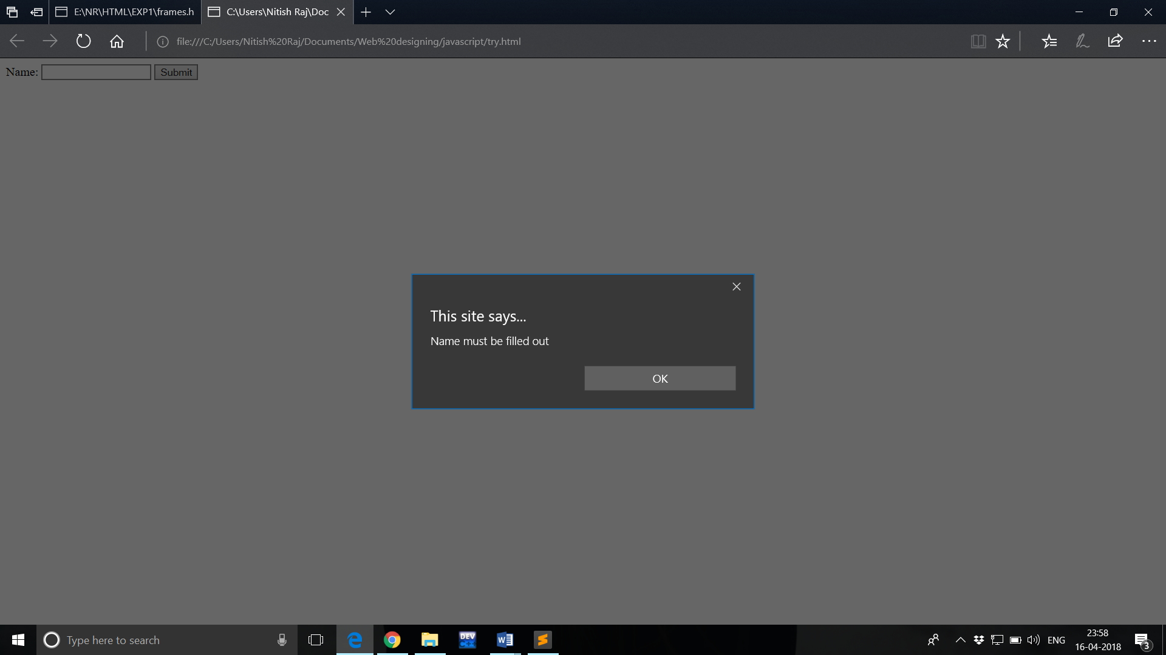

1. **Hiding and Showing elements**

<!DOCTYPE html>

<html>

<head>

<title>Hiding and Showing</title>

<script type="text/javascript">

function hd()

{

var x=document.getElementById("1");

if(x.style.display=="none")

x.style.display="block";

else

x.style.display="none";

}

</script>

</head>

<body bgcolor="lime">

<b>Click the TRY IT button to hide and show</b><br><br>

<input type="button" value="TRY IT" onclick="hd()">

<p id="1">

<b>Name : Nitish Raj<br>

Roll no : 11720068<br>

Branch : IT<br></b>

</p>

</body>

</html>

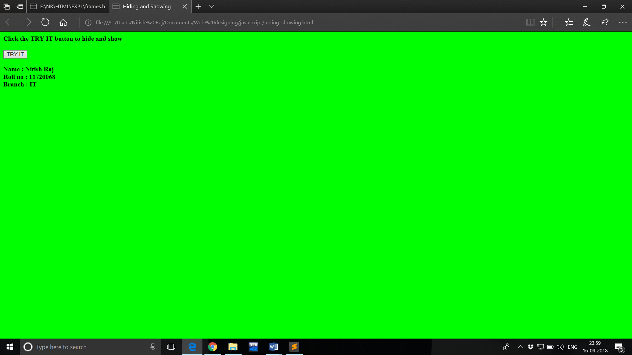

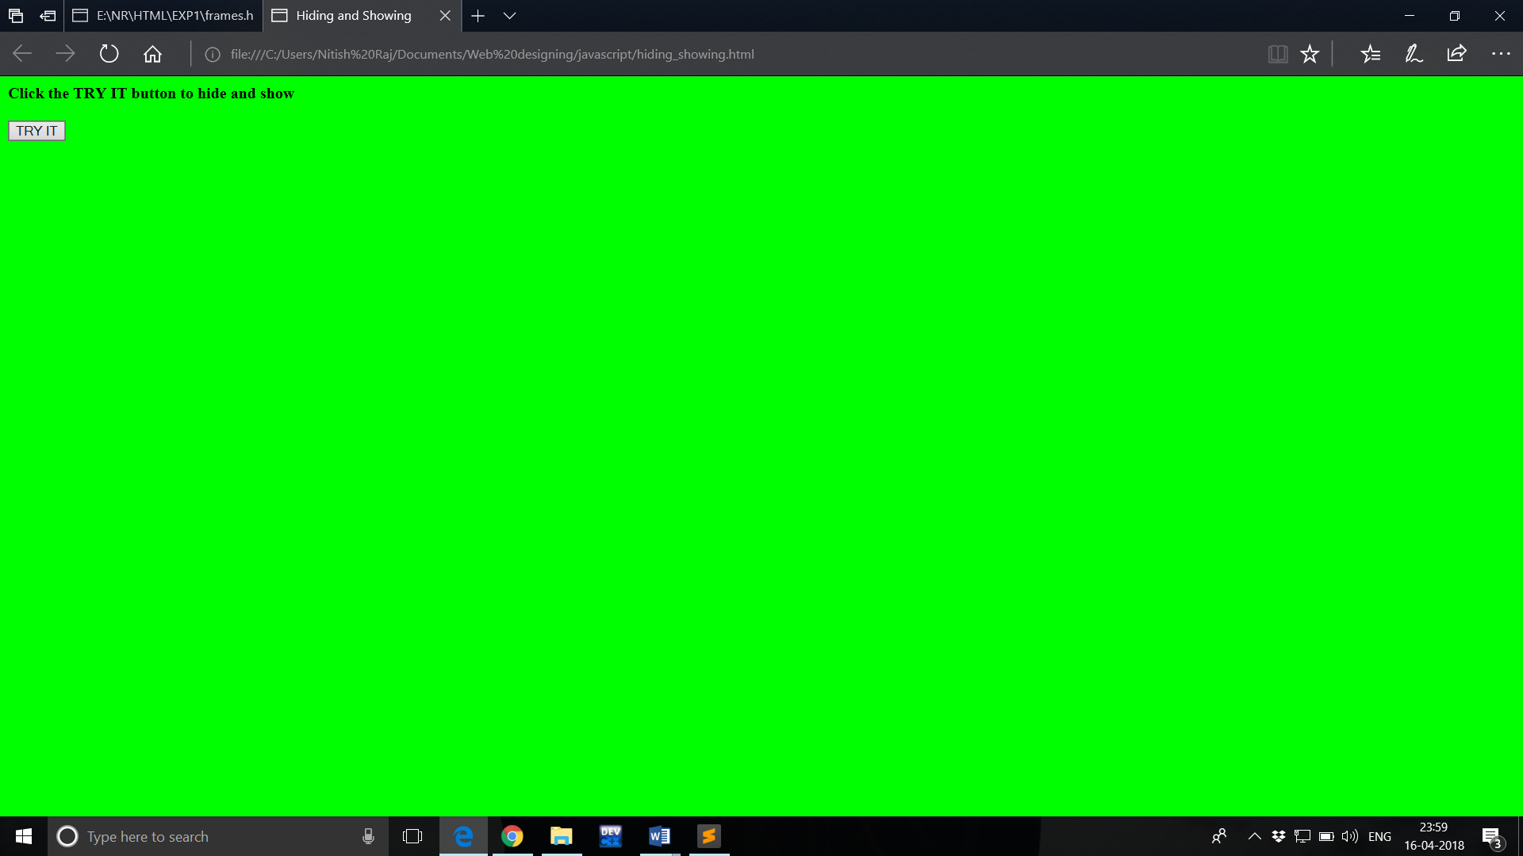

1. **Cookies**

<!DOCTYPE html>

<html>

<head>

<script>

function setCookie(cname,cvalue,exdays) {

var d = new Date();

d.setTime(d.getTime() + (exdays*24*60*60*1000));

var expires = "expires=" + d.toGMTString();

document.cookie = cname + "=" + cvalue + ";" + expires + ";path=/";

}

function getCookie(cname) {

var name = cname + "=";

var decodedCookie = decodeURIComponent(document.cookie);

var ca = decodedCookie.split(';');

for(var i = 0; i < ca.length; i++) {

var c = ca[i];

while (c.charAt(0) == ' ') {

c = c.substring(1);

}

if (c.indexOf(name) == 0) {

return c.substring(name.length, c.length);

}

}

return "";

}

function checkCookie() {

var user=getCookie("username");

if (user != "") {

alert("Welcome again " + user);

} else {

user = prompt("Please enter your name:","");

if (user != "" && user != null) {

setCookie("username", user, 30);

}

}

}

</script>

</head>

<body onload="checkCookie()">

</body>

</html>

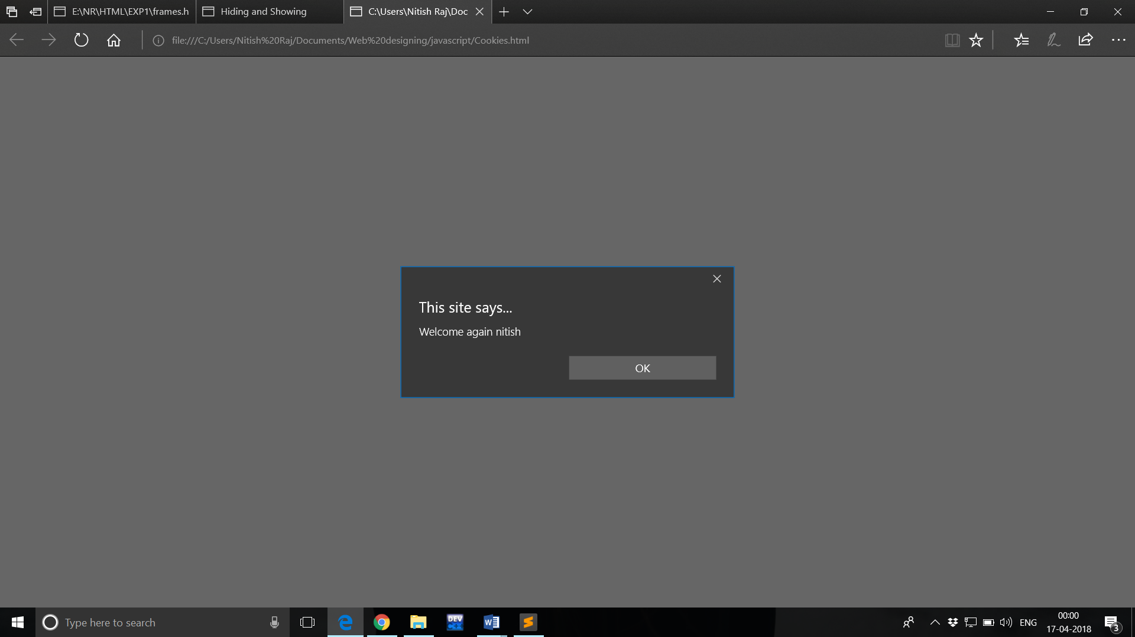

1. **Exception Handling**

<!DOCTYPE html>

<html>

<head>

<title>Try and catch</title>

<script type="text/javascript">

function tr()

{

var x=parseInt(document.f.x.value);

var y=parseInt(document.f.y.value);

try

{

if(y==0)

throw("Can't be divisible");

else

throw(x/y);

}

catch(er)

{

document.getElementById("1").innerHTML="Result is : "+er;

}

}

</script>

</head>

<body>

<form name="f">

Enter Number 1: <input type="text" name="x" value=""><br>

Enter Number 2: <input type="text" name="y" value=""><br><br>

<input type="button" value="Try" onclick="tr()">

<p id="1"></p>

</form>

</body>

</html>

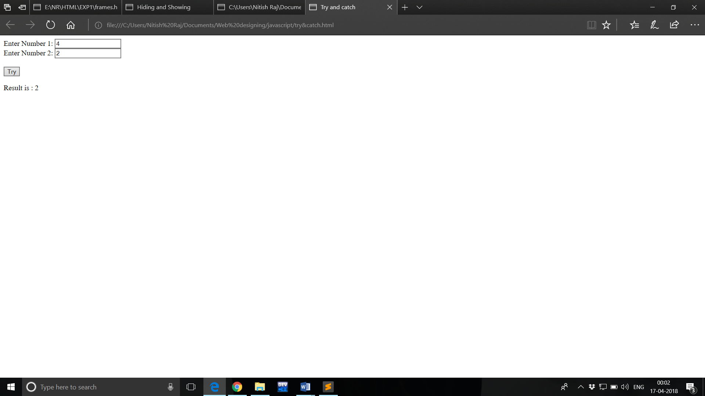

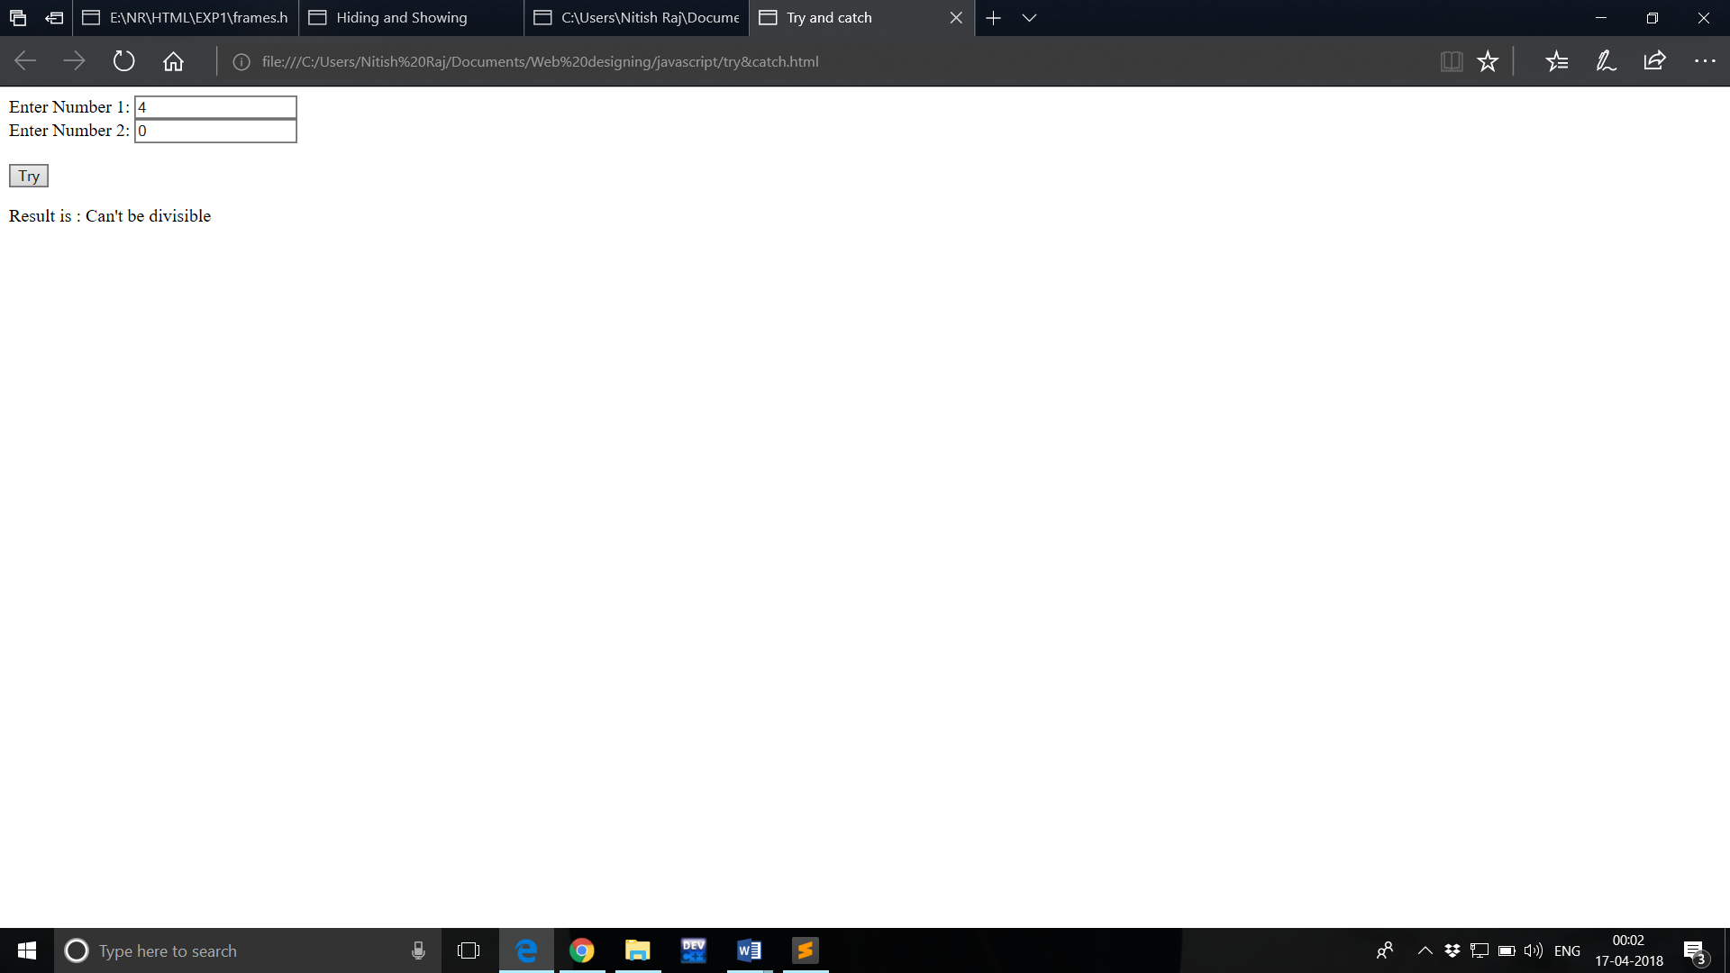

1. **Javascript Animation**

<!DOCTYPE html>

<html>

<style>

#container {

width: 400px;

height: 400px;

position: relative;

background: yellow;

}

#animate {

width: 50px;

height: 50px;

position: absolute;

background-color: red;

}

</style>

<body>

<p>

<button onclick="myMove()">Click Me</button>

</p>

<div id ="container">

<div id ="animate"></div>

</div>

<script>

function myMove() {

var elem = document.getElementById("animate");

var pos = 0;

var id = setInterval(frame, 5);

function frame() {

if (pos == 350) {

clearInterval(id);

} else {

pos++;

elem.style.top = pos + 'px';

elem.style.left = pos + 'px';

}

}

}

</script>

</body>

</html>

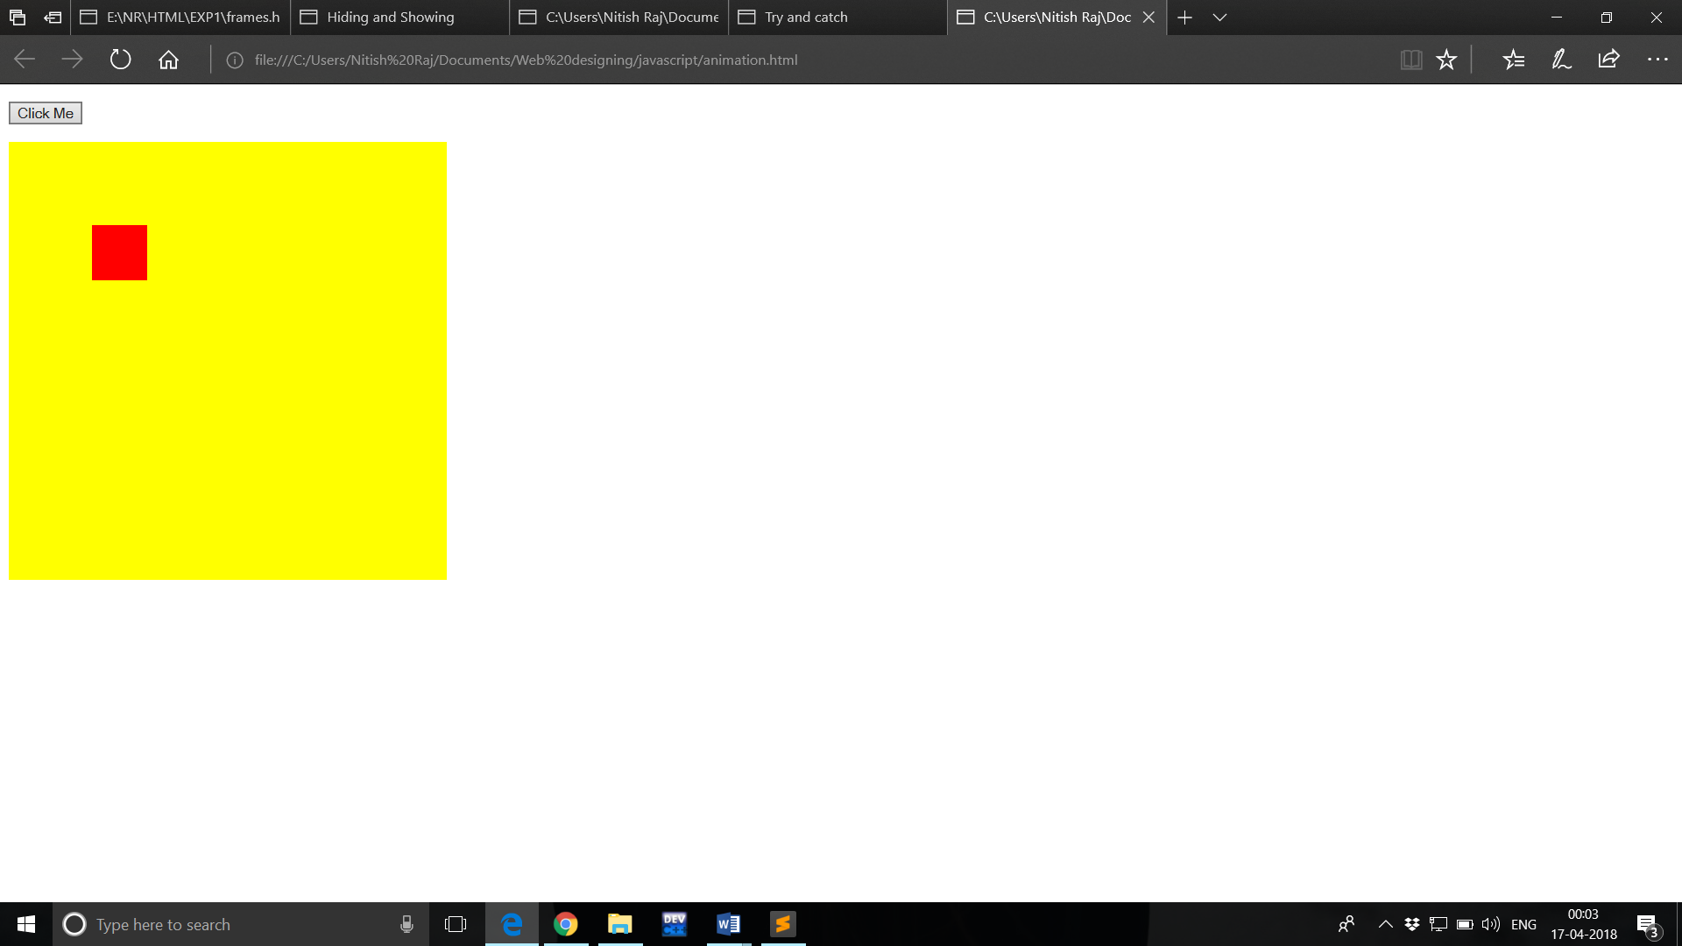

1. **CSS Box Model**

<html>

<head>

<style>

h2{

font-size: 50px;

text-align: center;

color: red;

}

div {

background-color: lightblue;

width: 350px;

border: 25px solid green;

padding: 25px;

margin: 35px;

font-size: 25px;

}

</style>

</head>

<body>

<h2>Cascading Style Sheet</h2>

<hr color="red">

<p><b><h3>The CSS box model is essentially a box that wraps around every HTML element. It consists of: borders, padding, margins, and the actual content.</h3></b></p>

<div>CSS stands for Cascading Style Sheets, it describes how HTML elements are to be displayed on screen, paper, or in other media. It saves a lot of work. It can control the layout of multiple web pages all at once External stylesheets are stored in CSS files</div>

</body>

</html>

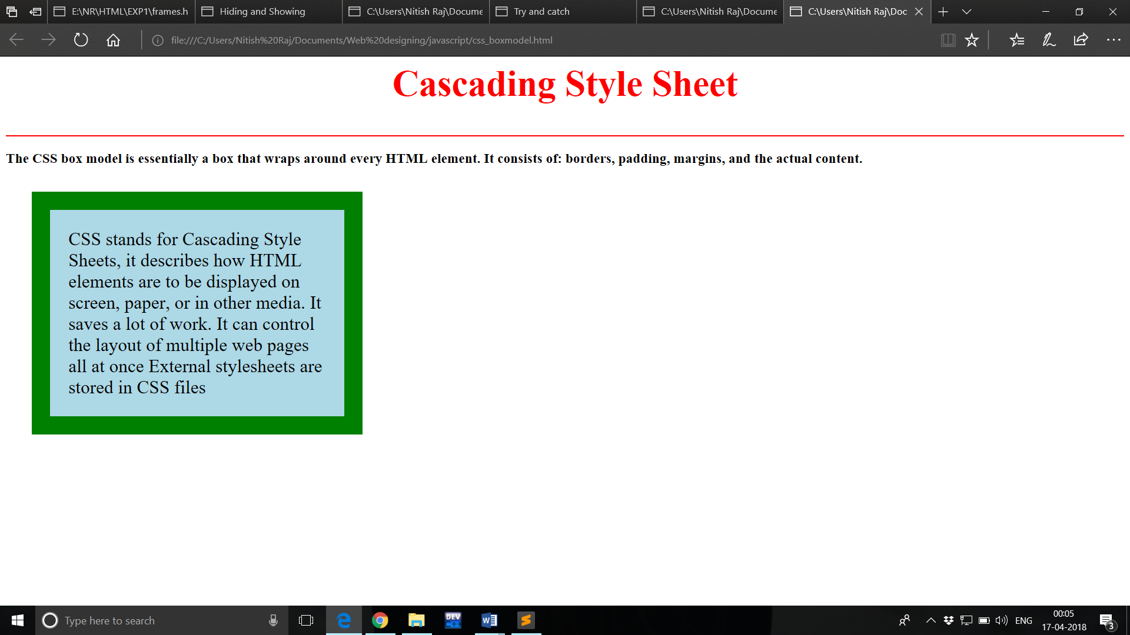

1. **Event Handling**
2. ONMOUSEOVER

<!DOCTYPE html>

<html>

<body>

<h1 onmouseover="style.color='red'" onmouseout="style.color='black'">Mouse over this text</h1>

</body>

</html> 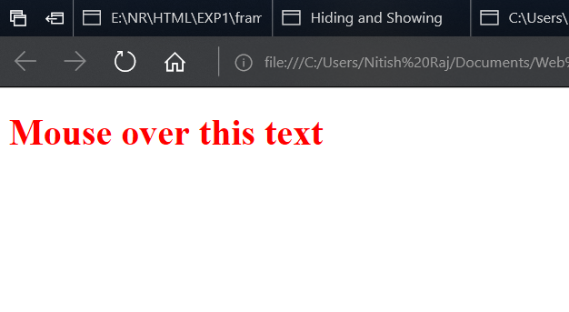

1. ONMOUSEDOWN

<html>

<head>

<script>

function myFunction(elmnt, clr) {

elmnt.style.color = clr;

}

</script>

</head>

<body>

<p onmousedown="myFunction(this,'red')" onmouseup="myFunction(this,'green')">

Click the text to change the color. A function, with parameters, is triggered when the mouse button is pressed down, and again, with other parameters, when the mouse button is released.

</p>

</body>

</html>



1. ONMOUSECLICK

<!DOCTYPE html>

<html>

<head>

<script>

function myFunction() {

document.getElementById("demo").innerHTML = "Hello World";

}

</script>

</head>

<body>

<p>Click the button to trigger a function.</p>

<button onclick="myFunction()">Click me</button>

<p id="demo"></p>

</body>

</html>

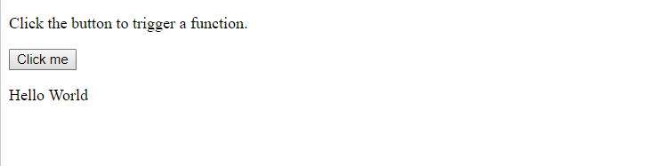

1. ONKEYPRESS

<html>

<head>

<script>

function myFunction() {

alert("You pressed a key inside the input field");

}

</script>

</head>

<body>

<p>A function is triggered when the user is pressing a key in the input field.</p>

<input type="text" onkeypress="myFunction()">

</body>

</html>

1. ONKEYDOWN

<html>

<head>

<script>

function myFunction() {

alert("You pressed a key inside the input field");

}

</script>

</head>

<body>

<p>A function is triggered when the user is pressing a key in the input field.</p>

<input type="text" onkeydown="myFunction()">

</body>

</html>